**UML DIAGRAMS**

* Use case diagram for Doctor

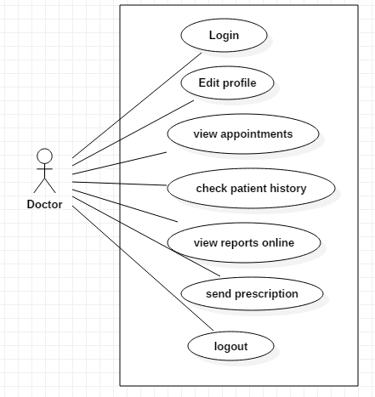

* Use case diagram for Patient

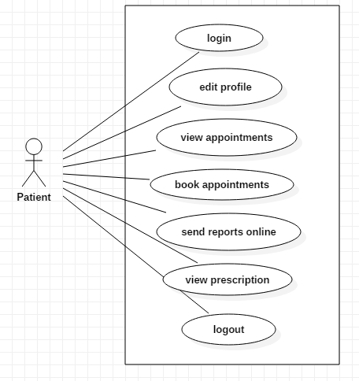

* ER diagram for Doctor

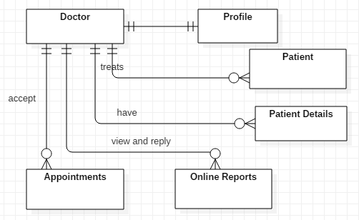

* ER diagram for Patient

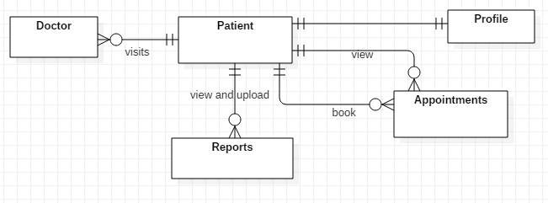

* Activity diagram for doctor login

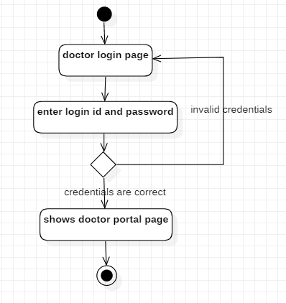

* Activity diagram for doctor profile updation

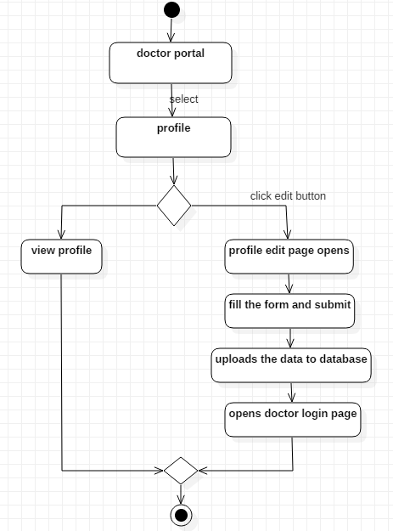

* Activity diagram to view appointment and cancel appointment by doctor

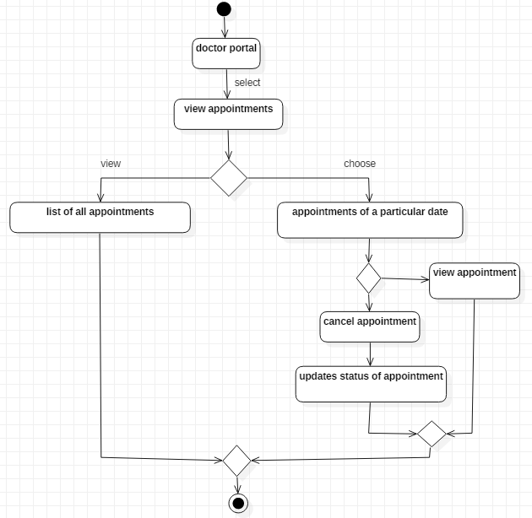

* Activity diagram for patient details in doctor portal

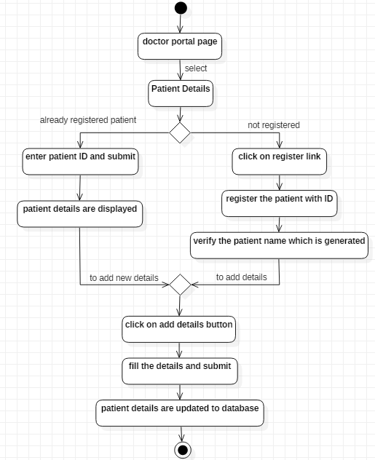

* Activity diagram for patient reports and prescription by doctor

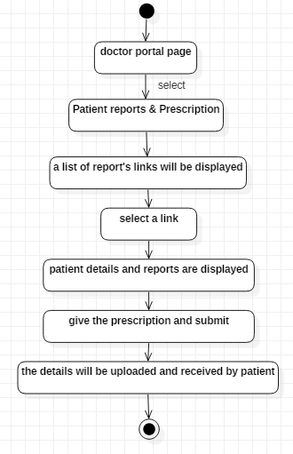

* Activity diagram for patient login

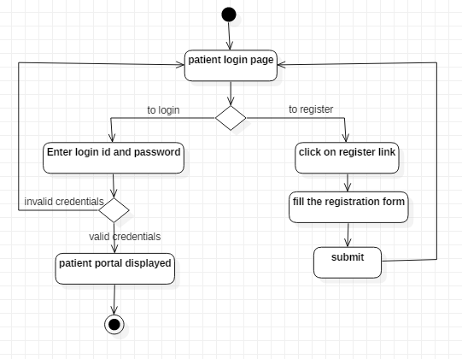

* Activity diagram for patient profile updation

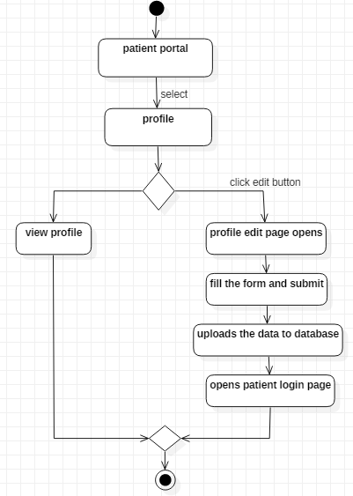

* Activity diagram to view appointment and cancel appointment by patient

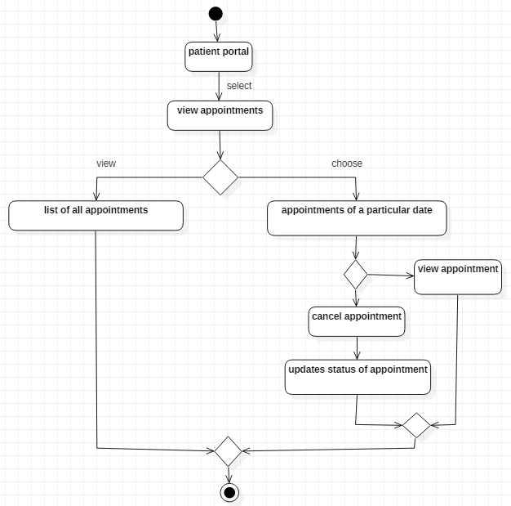

* Activity diagram to book appointment

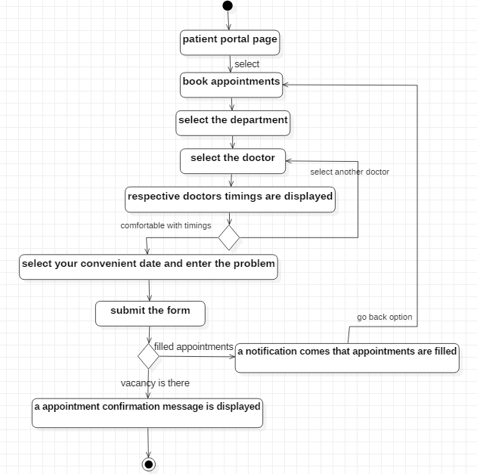

* Activity diagram to upload patient reports and get prescription

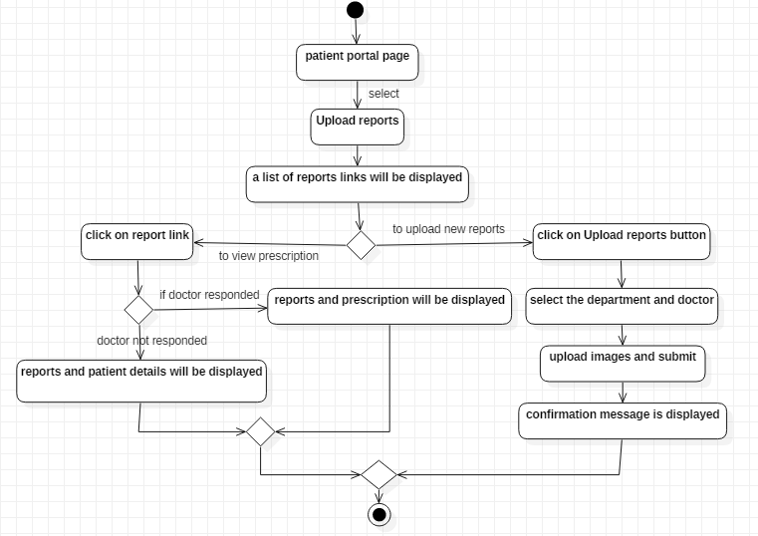

* Sequence diagram for booking appointment and find status

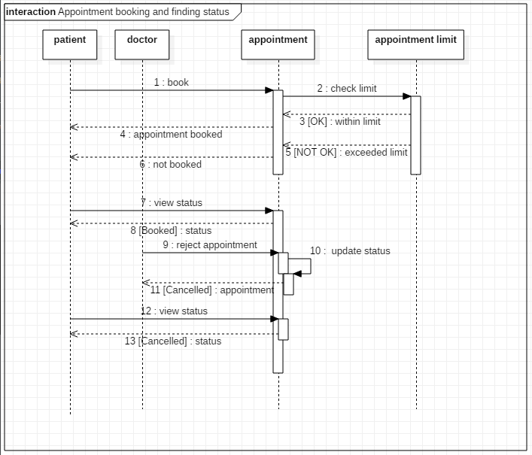

* Sequence diagram for uploading reports and receive prescription

